ISLAMABAD MODEL COLLEGE FOR BOYS
F-10/4 ISLAMABAD

BANK MANAGEMENT SYSTEM

SUBMITTED BY:

Obaid Ullah (16HC039)

Class: 2nd Year
Section: ICs

SUBMITTED TO:

Sir Abaid Ullah Shah

Date:

Signature: _____________

- ACKNOWLEDGEMENT

FIRST OF ALL THANKS TO ALLAH
THEN,
WE DEDICATED THIS LITTLE EFFORT TO
OVER BELOVED TEACHER
“SIR Abaid Ullah Shah”
&
PARENTS
WHO’S PRAYERS MADE AS ABLE TO DO SUCH
WORTH WHILE JOB.

Preface

This project report presents a description of analysis related to the problem of starting all the bank data management manually. This report also presents the development of a system designing & its implement.

The representation of data of all aspects include a brief description of database, which we have prepared to avoid the complication complexities which one has face with, especially during the extraction of data or any other record concerning with BANK MANAGEMENT SYSTEM.

TABLES OF CONTENTS:

CHAPTER NO.1 INTRODUCTION:

- Introduction to bank
- Current manual system
- Draw backs of current manual system.
- Advantage of computerized system.

CHAPTER NO.2: DOCUMENTATION:

- Software Requirement.
- Hardware Requirement.

CHAPTER NO.3: USER DOCUMENTATION:

- Tables.
- Queries.
- Forms.
- Reports.
- Switch board.

CHAPTER NO.4: RELATION DIAGRAM:

CHAPTER NO.5: SUMMARY.

CHAPTER NO. 1

INTRODUCTION TO

PROJECT.

ZARAI TARAQIATI BANK LIMITED

INTRODUCTION:

Introduce in 1952. In 1957, Agriculture Development Bank of Pakistan was established on December 14, 2002, the Federal Government has converted Agriculture Development Bank of Pakistan (ADBP) into ZTBL.
- Total Branches 355.
- 1st President & CEO was Mr.Istaqbal Mehidi.
- Ownership Government.
- Type of Institution-Specialized Bank.
- Established 1961.
- Chairman Sultan Ali Chaudhary.
- President & CEO. Ms Roohi Raees Khan.
- EVO- HR- Masghar.
- Headquarter- Islamabad Pakistan.
- Total Assets – PKR 102.371 billions.
- Total Revenue- PKR 8.484 billions.
- Total Employee- 5500.
- Total Zone- 31.

- CURRENT MANUAL SYSTEM:
In bank management system money can be deposited in the bank after opening an account balance the money which can be withdrawn is called deposited more money is called credit.

- OBJECTIVE:

- To reduce paper work
- To save time.
- Searching record is quickly.
- To access, update & delete easily & quickly,

  - DRAWBACKS OF MANAUAL SYSTEM:
- Data redundancy.
- Data inconsistency.
- Program data dependence.
- Lack of flexibility.
- Data was not shareable.

  - ADVANTAGES:
- Saves our time.
- Is to update, access, delete & search the record.
- It reduces stationary work.

CHAPTER NO.2

TECHNICAL DOCUMENTATION

  - Click on start button & select MS.Access.

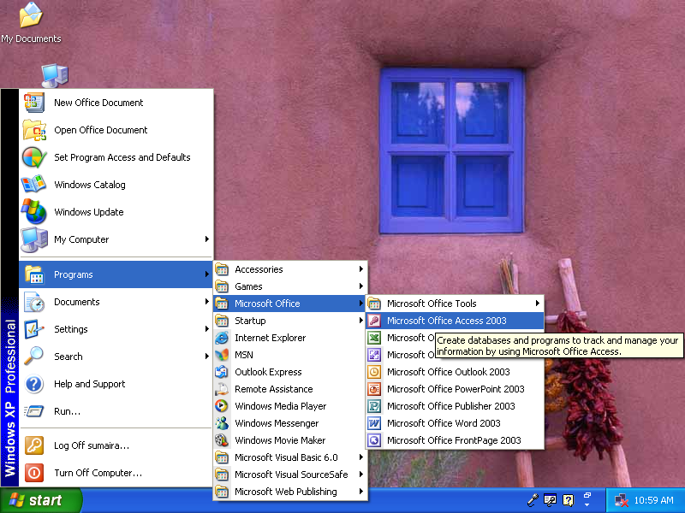

  - click on MS.Access & open database.

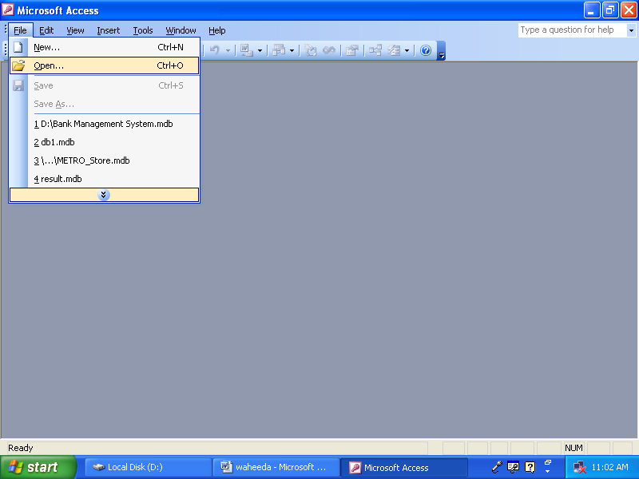

CHAPTER NO.3

USER DOCUMENTATION

SWITCHBOARD

      - MAIN SWITCHBOARD:
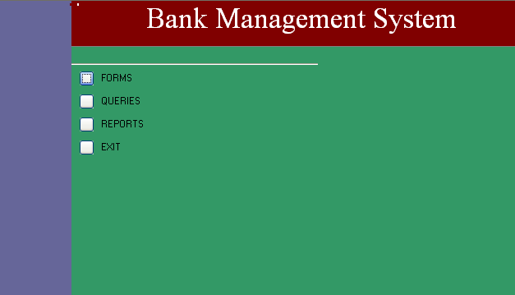

- FORMS SWITCHBOARD:
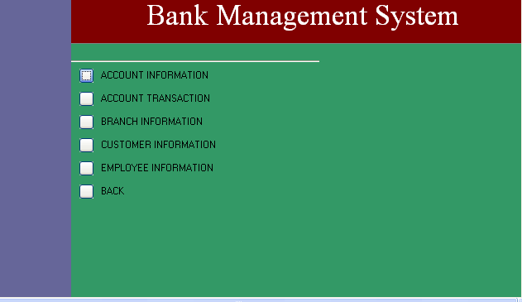
- REPORTS SWITCHBOARD:

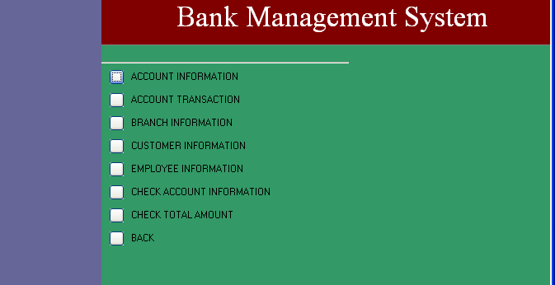

- QUERIES SWITCHBOARD:

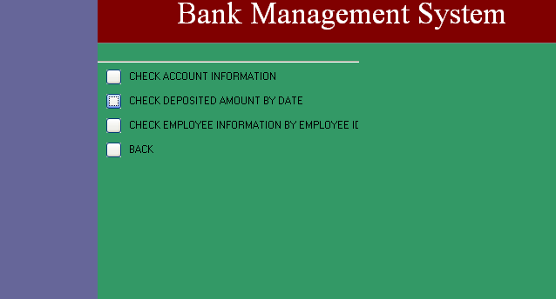

- TABLES

1. ACCOUNT INFORMATION:

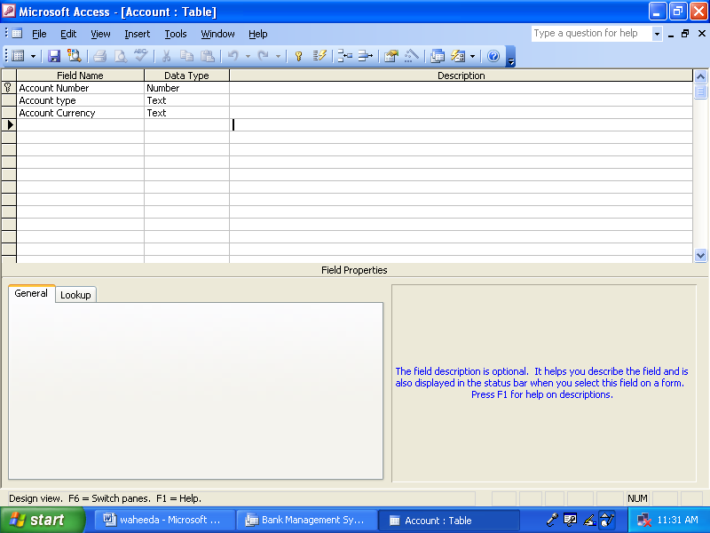

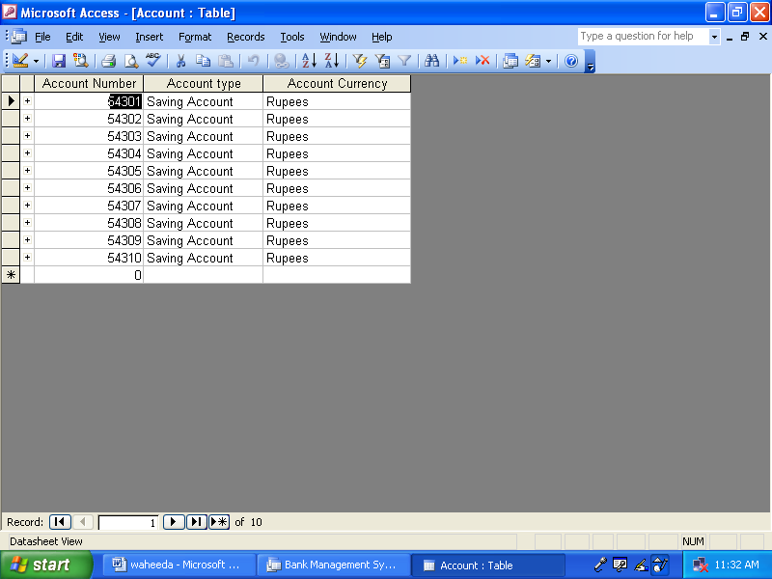

  - CUSTOMER INFORMATION:

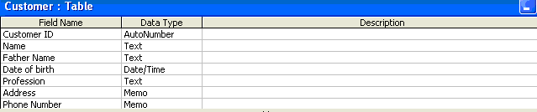

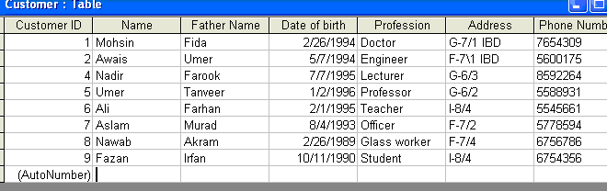

BRANCH INFORMATION:

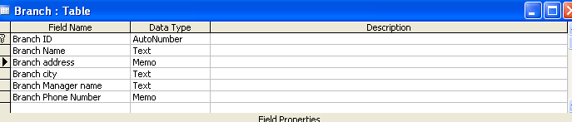

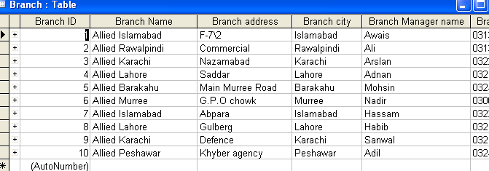

  - EMPLOYEE INFORMATION:

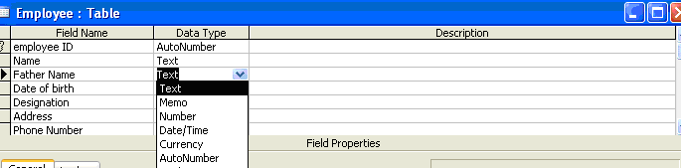

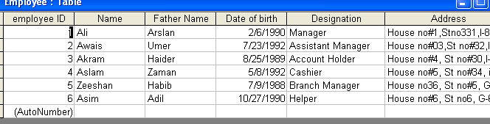

  - QUERIES

  - CHECK ACCOUNT BALANCE SHEET:

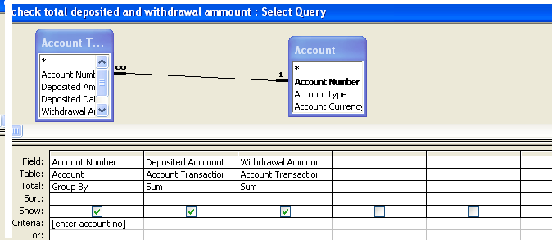

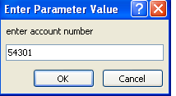

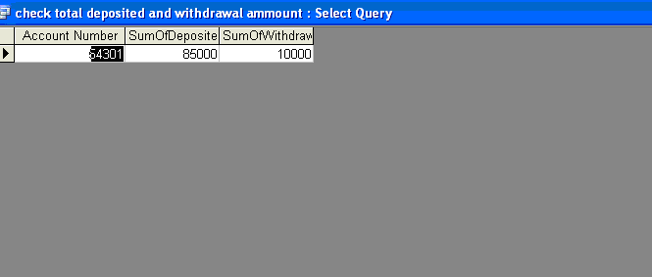
  - Check customer account information by id:

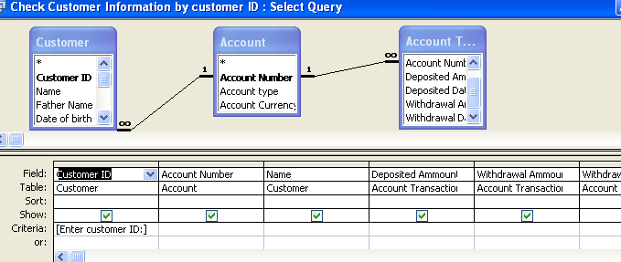

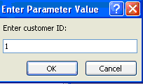

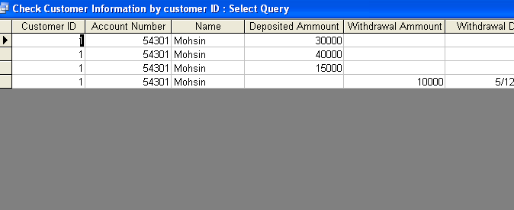

  - check customer information by account number:

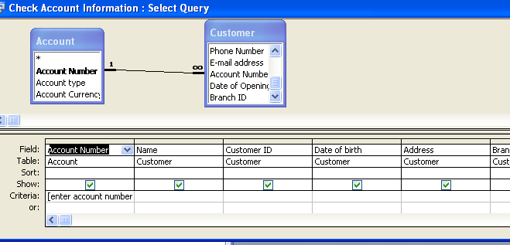

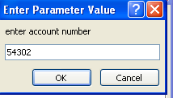

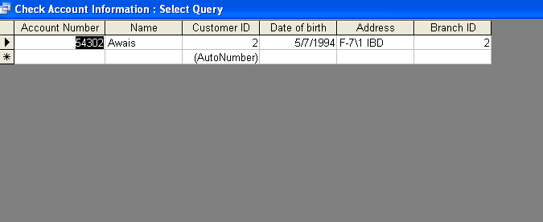

  - check employee information by id:

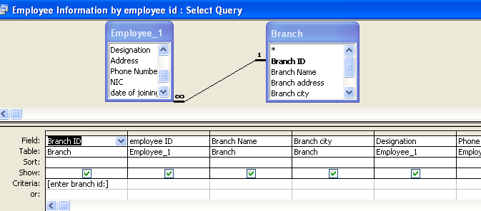

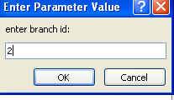

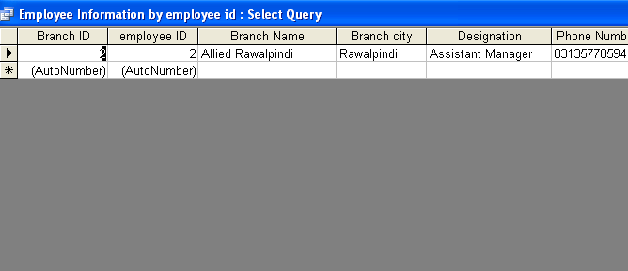

  - forms

    - account transaction:

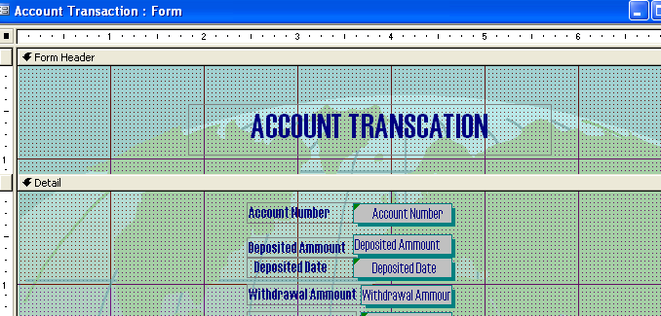

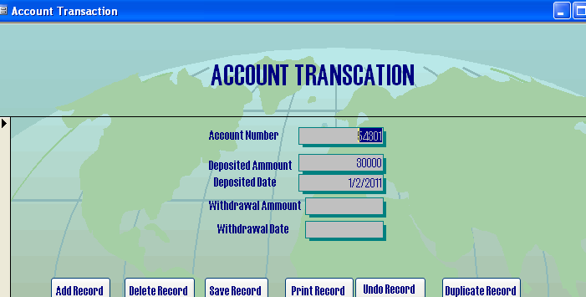

    - branch information:

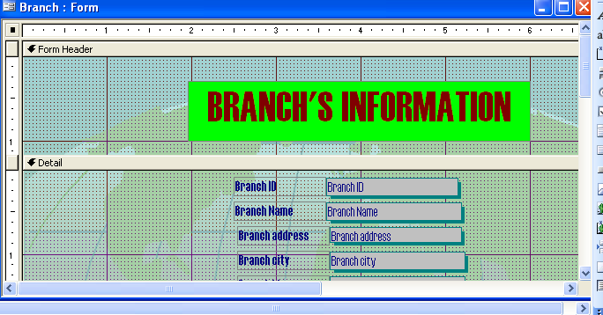

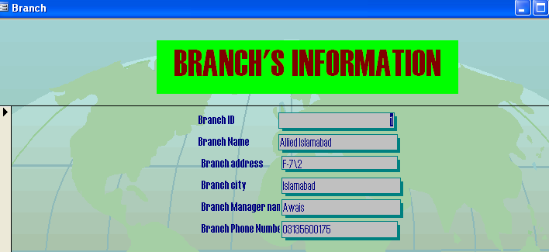

3.account information:
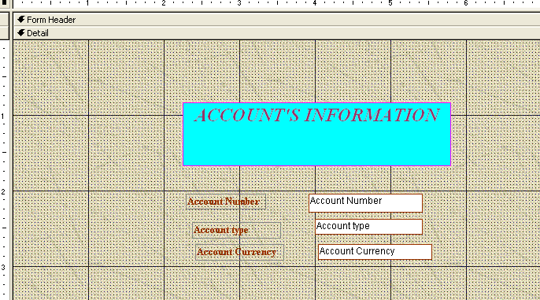

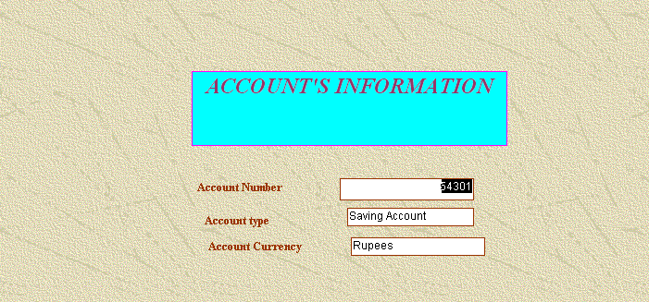

    - customer information by account number:

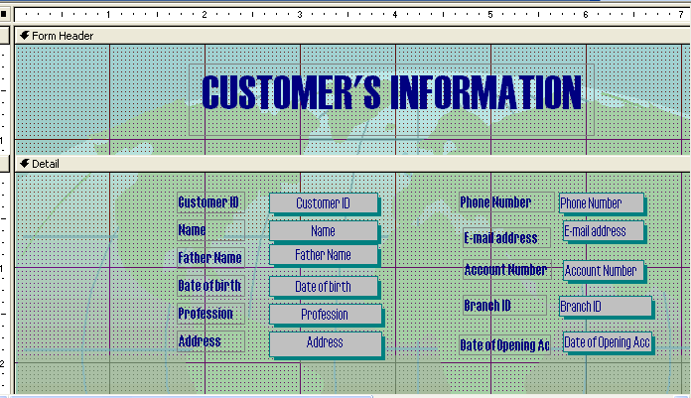

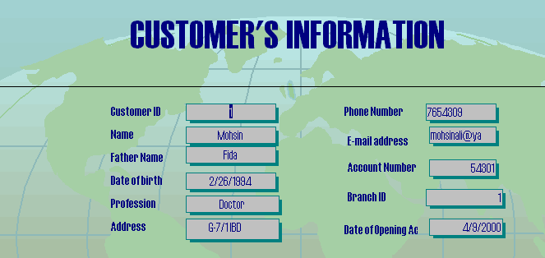

    - employee information:
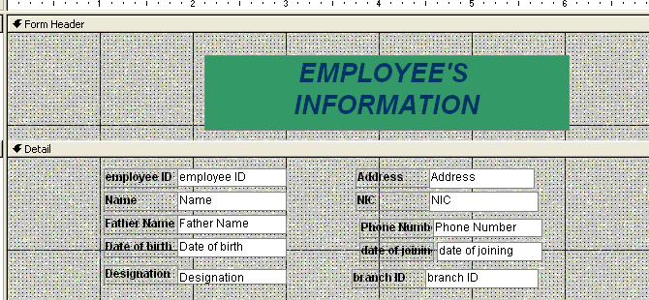

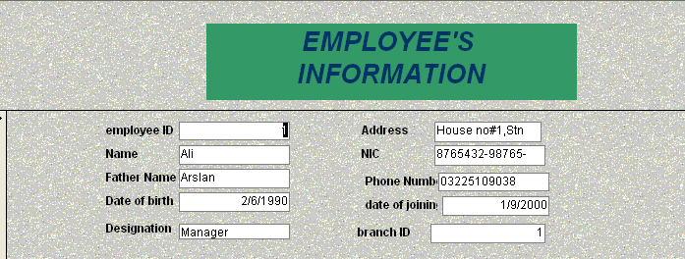

    - check deposited ammount:

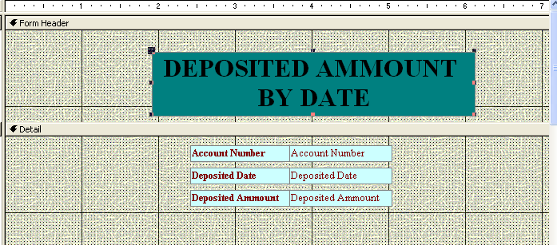

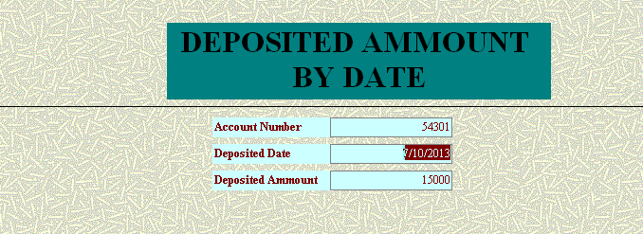

    - employee information by id:

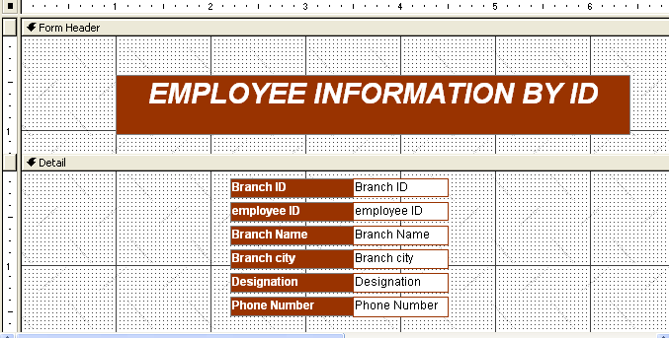

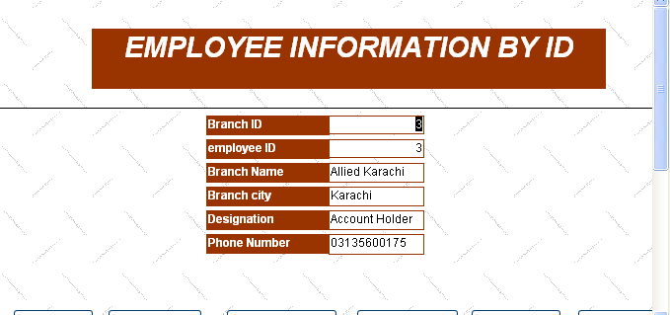

  - reports

- we have 6 reports:

- account transaction:

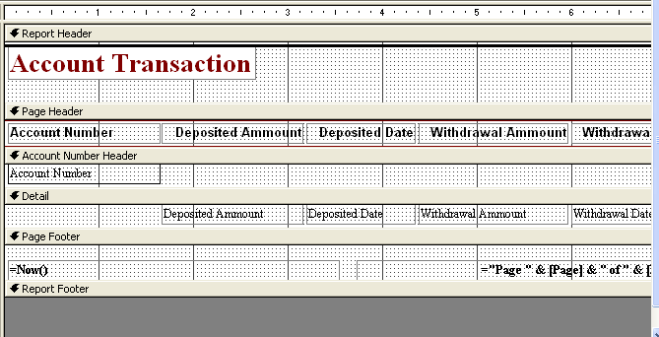

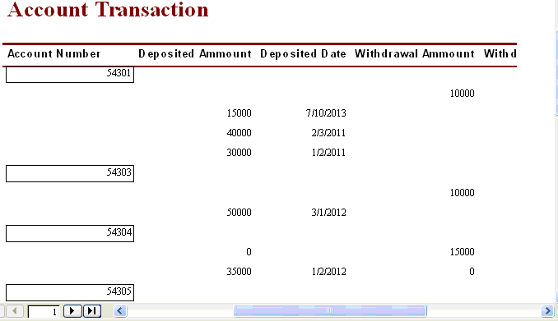

2.branch information:

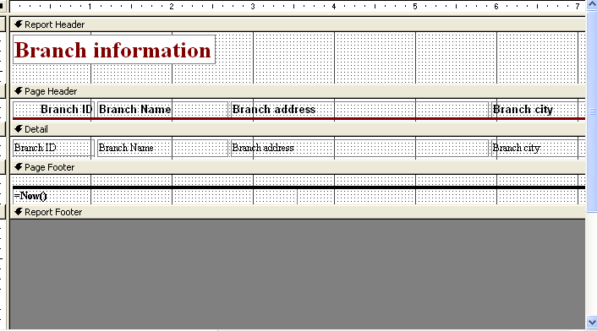

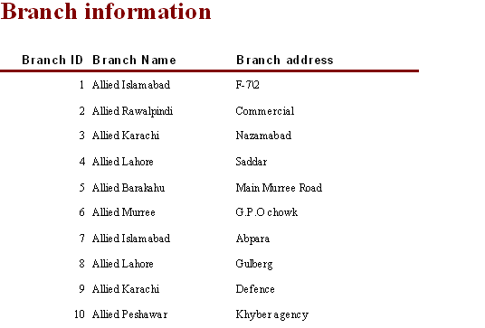

- account balance sheet:

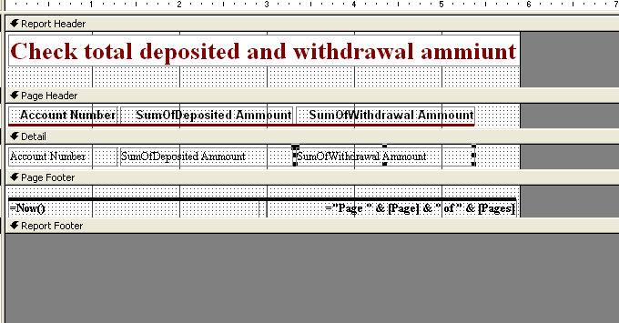

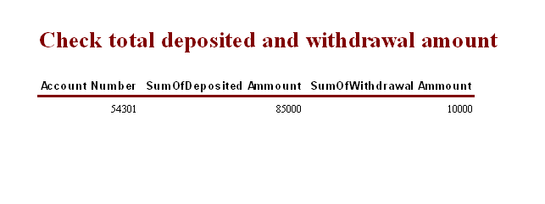

- customer information:

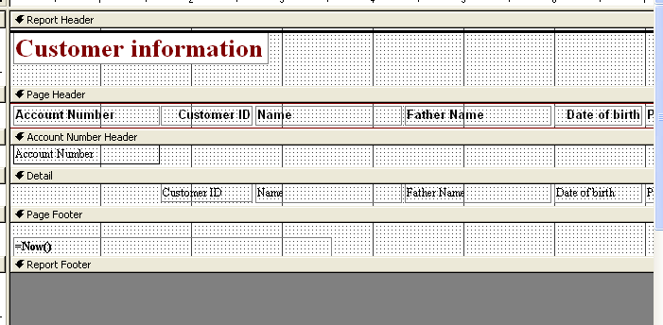

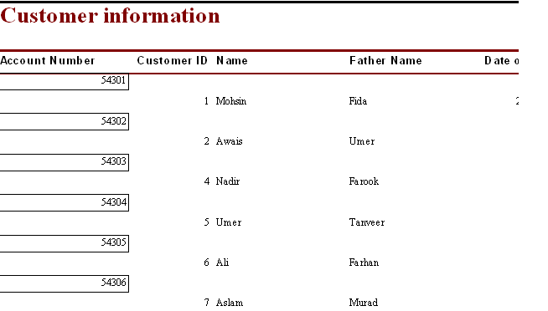

- customer information by customer id:

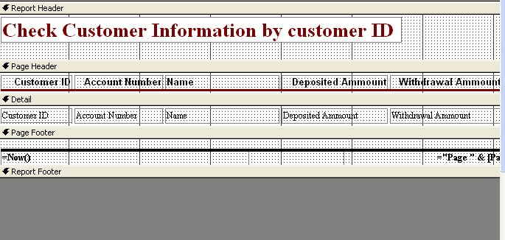

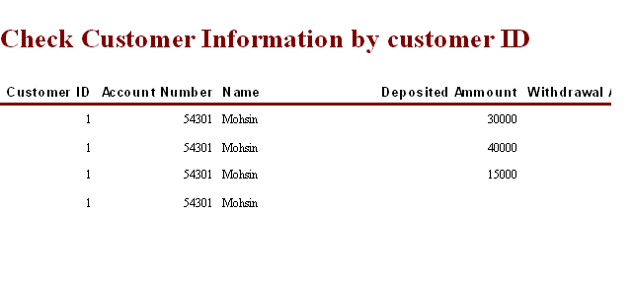

- employee information:

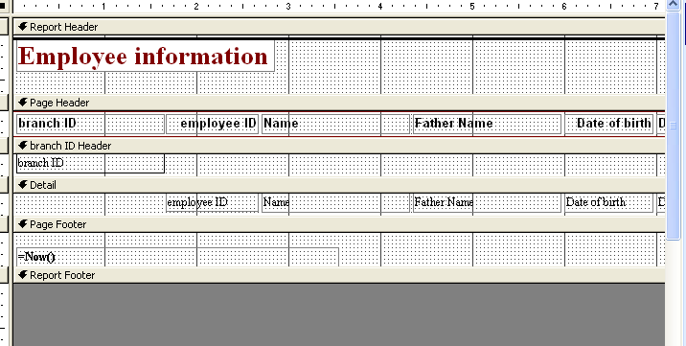

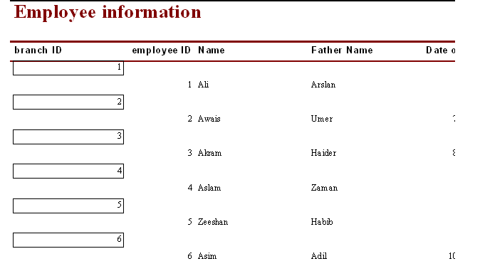

chapter no : 4

entity –
relationship
diagram

  - entity relationship diagram:

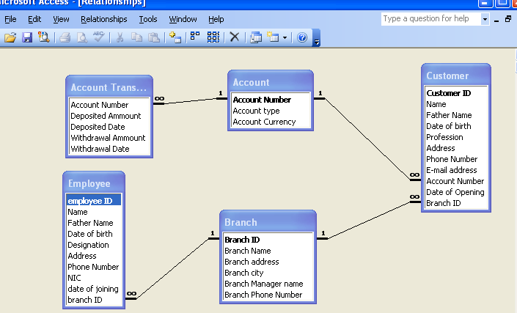

chapter no: 5

summary

  - summary

since this was a communication project, various entities are used first of all we created database i.e.customer, account etc.
branches such that tables. fOur tables are created. their physical design & logical relationship is created. this is called entity relationship diagram. then forms are design to show the data table and queries. the project is submitted is hard copy and also as a soft copy. this bank store information system database has been installed on the system of bank. they are successfully running their data on the database.

regular testing & maintenance steps are being taken by us.

